Question 1: Create an expanded menu bar which on expansion shows the subcategory of the product items.

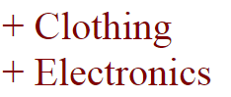

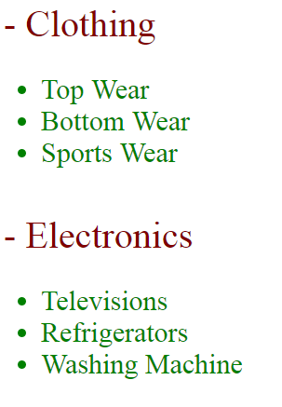

Question 2: Create a form having two text boxes (for username and password) and make it as a mandatory field (validate whether the user input the data or not) when user clicked the submit button